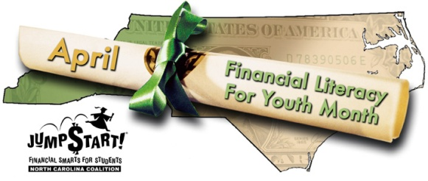

Nomination form for NC Jump$tart Award for Outstanding Contributions to Financial Education for Youth
The North Carolina Jump$tart Coalition annually presents an award to an individual or organization that has made outstanding contributions in educating the youth of North Carolina about personal finances. If you would like to nominate someone for the 2012 award, please complete this nomination form and submit to Tami Hinton at thinton@nccob.gov.

Individual or Organization Name: ___________________________________________________
Address: _______________________________________________________________________
Email: _______________________________________ Phone: ___________________________
Number of Years involved in efforts supporting Financial Literacy: __________________
Please list specific contributions this individual or organization has made to Financial Literacy in 2012:

Please explain why this individual or organization should receive this award:

Nominated by: _________________________ Phone #: ________________ Email: _________________

